**NAME – KHUSHI PANWAR, khushipanwar26@gmail.com**

**ROLL NO – 2021334**

**C++ PRACTICAL ASSIGNMENT – 30 DEC 2021**

1. **Write a program that prints pascal’s triangle:**

#include<iostream>

using namespace std;

int main(){

    int rows;

    cout<<endl<<"Enter the number of rows : ";

    cin>>rows;

    cout<<endl;

    for (int i=0; i<rows; i++){

        int val=1;

        for (int j=1; j<(rows-1); j++){

            cout<<" ";         }

        for (int k=0; k<=i; k++){

            cout<<" "<<val;

            val=val*(i-k)/(k+1);

        }

        cout<<endl<<endl;

    }

    cout<<endl;

    return 0;

}

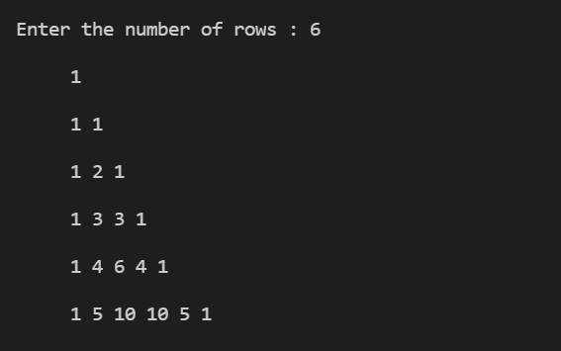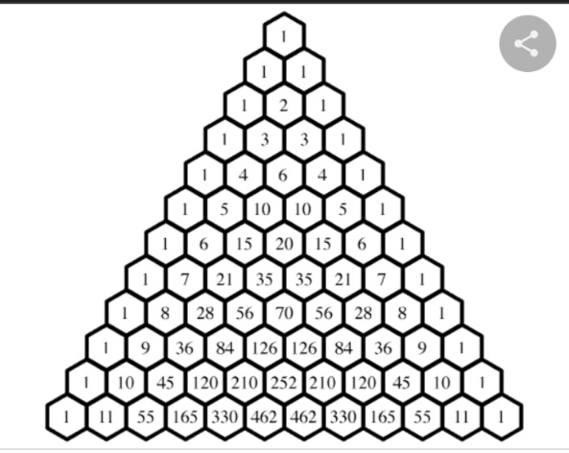

1. **Program to find the sum of the series using functions:**

**S = 1/1! + 1/2! + 1/3! + 1/4! + ….1/n!**

#include<iostream>

using namespace std;

int fact(int i)

{

    int pro=1;

    for (int k=1;k<=i;k++)

        pro=pro*k;

    return pro;

} //function fact

int main(){

    cout<<"\t* THIS PROGRAM FINDS THE SUM OF SERIES * "<<endl;

    cout<<endl<<"s=1/1!+1/2!+1/3!--- 1/n!"<<endl;

    double sum=0;

    int n;

    cout<<"-> Enter the value of n : ";

    cin>>n;

    for (int i=1;i<=n;i++){

        int x=fact(i);

        sum=sum+1.0/x;

    }   //cout<<1;

    cout<<"-> The Sum of series is "<<sum;

    return 0;

}

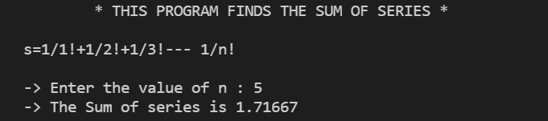

1. **Write a Program to display Fibonacci series using function.**

**1,2,3,5,8….. (**consists of sum of the two preceding numbers**)**

#include <iostream>

#include <iomanip>

using namespace std;

void fibonacciSeries(int num, int t1, int t2){

    int n=3;

    while (n<=num){

        int sum=t1+t2;

        cout<<setw(4)<<sum;

        t1=t2;

        t2=sum;

        n++;

    }

return;

}

int main(){

    int terms, t1, t2;

    cout<<endl<<"\t * FIBONACCI SERIES USING FUNCTIONS * "<<endl<<endl;

    cout<<"How many terms do you want in this fibonacci series : ";

    cin>>terms;

    cout<<endl;

    cout<<"Enter the first two terms of Fibonacci series : ";

    cin>>t1>>t2;

    cout<<endl;

    cout<<setw(4)<<t1<<setw(4)<<t2;

    fibonacciSeries(terms, t1, t2);

cout<<endl;

    return 0;

}

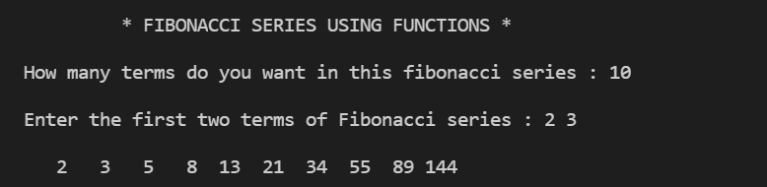

1. **Write a Program to check whether the given no is prime number or not.**

#include<iostream>

#include<iomanip>

using namespace std;

void primeTest(int num){

    int k=2;

    int flag=0;

    while(k<num){

        if (num%k==0) flag=1;

        k++;

    }

    if (flag!=1) cout<<"\t->"<<num<<" is the Prime Number"<<endl<<endl;

    else cout<<"\t->"<<num<<" is a Composite Number."<<endl<<endl;

    return ;

}

int main(){

    cout<<setw(45)<<"\n __* PRIME - COMPOSITE NUMBER TEST *__"<<endl;

    int num;

    char ch='y';

    while (ch=='y'){

        cout<<"Enter the number : ";

        cin>>num;

        primeTest(num);

        cout<<"Do you wish to continue (y/n)?? ";

        cin>>ch;

    }

    cout<<"\t *PROGRAM ENDS HERE* "<<endl;

    return 0;

}

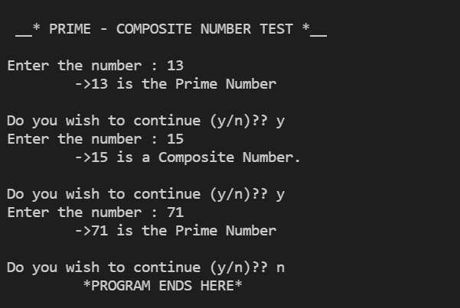

1. **Write a Program to perform different operations on the given values. (The Calculator Program)**

#include<iostream>

#include<iomanip>

using namespace std;

int getInput(){

    int num;

    cout<<"Enter a numerical value here : ";

    cin>>num;

    return num;

}

int operations(int a, int b, char ch){

    int z;

    switch(ch){

        case '+' :  z=a+b;

                    break;

        case '*' :  z=a*b;

                    break;

        case '/' :  z=a/b;

                    break;

        case '%' :  z=a%b;

                    break;

        default: cout<<"Invalid Operation";

    }

    return z;

}

int main(){

    char ch,ch1;

    int a,b,z;

    ch1='y';

    cout<<"================="<<endl;

    cout<<" + for Addition"<<endl<<" * for Multiplication"<<endl<<" / for

Division"<<endl<<" % for Modulus"<<endl;

    cout<<"================="<<endl;

    while (ch1=='y') {

        a = getInput();

        b = getInput();

        cout<<"\t -> a = "<<a<<endl<<"\t -> b = "<<b<<endl;

        cout<<endl<<"Enter the operation you want to perform : ";

        cin>>ch;

        z=operations(a,b,ch);

        cout<<"\t -> The Result of Operation = "<<z<<endl;

        cout<<endl;

        cout<<"Do you want to continue y/n : ";

        cin>>ch1;

    }

    cout<<"\t * Program ends here! * "<<endl;

    return 0;

}

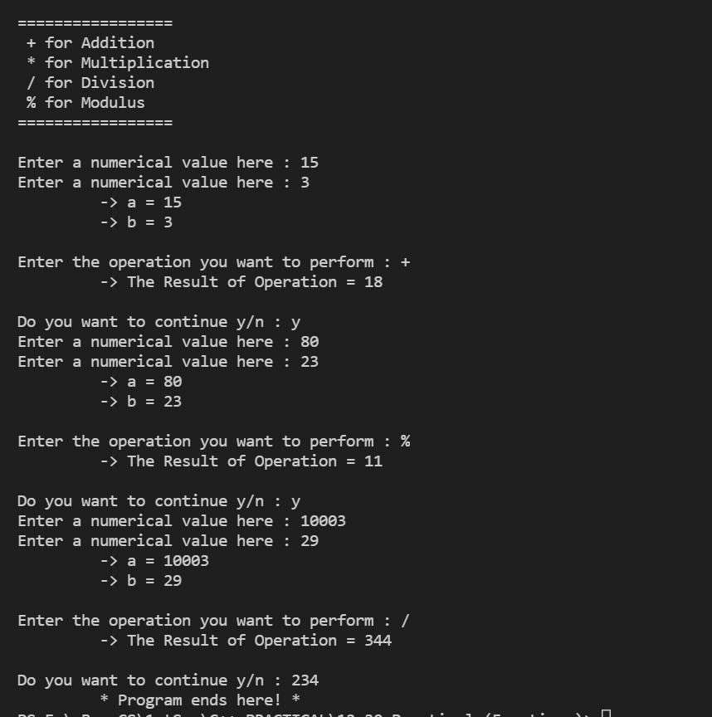

1. **Write a Program to print different patterns using functions.**

#include<iostream>

#include<iomanip>

using namespace std;

void pyramid1(){

    cout<<endl;

    for (int i =0; i<=5; i++) {

            for (int j=1; j<=i;j++){

            cout<<" * " ;

            }

    cout<<endl;

    }

    return;}

void pyramid2(){

    for (int i=5; i>=0; i--) {

            for (int j=0; j<=i;j++){

            cout<<" * " ;

            }

    cout<<endl; }

    return ;

}

void pyramid3(){

    cout<<endl;

    char ch='A';

    for (int i =0; i<=5; i++) {

            for (int j=0; j<=i;j++){

            cout<<ch<<" "; }

    ch++;

    cout<<endl;

    }

    return;

}

void pyramid4(){

    for (int i =0; i<=5; i++) {

            for (int j=1; j<=i;j++){

            cout<<j<<" ";

            }

    cout<<endl;

    }

    return;

}

void pyramid5(){

    for (int i=5; i>=0; i--) {

        for (int j=1; j<=i;j++){

        cout<<j<<" "; }

    cout<<endl;

    }

    return;

}

void pyramid6(){

    int j=1;

    int i;

    int max=10;

    for (i =1; i<=5; i++) {

            cout<<setw(max);

            for (int k=i; k<=j;k++)

                cout<<k;

            for (int u=j-1; u>=i; u--)

                cout<<u;

            cout<<endl;

            j=j+2;

            max=max-1;

            }

    return;

}

int main(){

    cout<<setw(40)<<" * DISPLAY VARIOUS PATTERNS * "<<endl;

    cout<<endl;

    cout<<"=============================="<<endl;

    cout<<"\tPRESS : "<<endl;

    cout<<"1 for Ascending Pyramid of *"<<endl;

    cout<<"2 for Descending Pyramid of *"<<endl;

    cout<<"3 for Ascending Pyramid of Alphabets"<<endl;

    cout<<"4 for Ascending Pyramid of Numbers"<<endl;

    cout<<"5 for Descending Pyramid of Numbers"<<endl;

    cout<<"6 for Dynamic Full Pyramid"<<endl;

    cout<<"=============================="<<endl;

    cout<<endl;

    int choice;

    char run='y';

    while (run=='y'){

    cout<<"Enter your choice here: ";

    cin>>choice;

    switch (choice){

        case 1 : pyramid1();

                break;

        case 2 : pyramid2();

                break;

        case 3 : pyramid3();

                break;

        case 4 : pyramid4();

                break;

        case 5 : pyramid5();

                break;

        case 6 : pyramid6();

                break;

        default : cout<<"Invalid Choice. Try again!"<<endl;

    }

    cout<<endl<<"Do you want to continue?? (y/n) ";

    cin>>run;

    cout<<endl;

    }

    cout<<endl<<" * PROGRAM ENDS HERE * "<<endl;

    return 0;

}

